Yanika Francis

CS – 255

Prof. Kinkela

SNHU

August 15, 2025

## UML Diagrams

### 

### UML Activity Diagrams

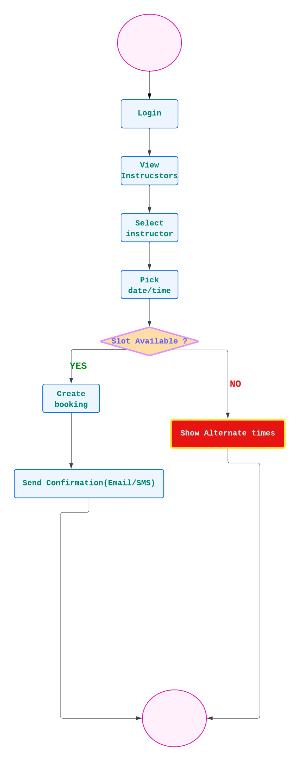

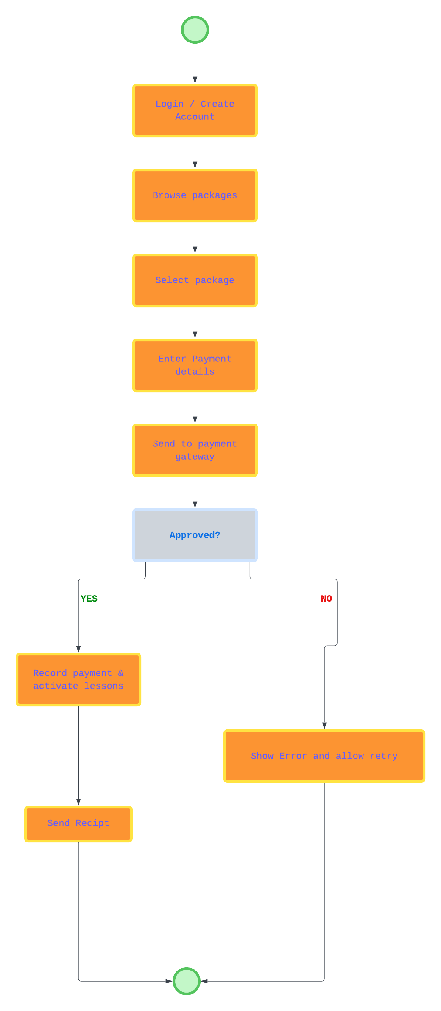

### UML Sequence Diagram

### UML Class Diagram

## Technical Requirements

The DriverPass system will run as a web application, allowing students, instructors, and administrators to access it from any location.

* **Hardware:** A cloud server will host the website and a database. Users only need a computer or phone with internet access.
* **Software:** The website will be built with a common web framework (like React or Angular) and connect to a backend (Java or .NET) with a SQL database such as MySQL or PostgreSQL.
* **Tools:** Developers will use Lucidchart for diagrams, GitHub for version control, and an IDE like VS Code or Eclipse.
* **Infrastructure:** The system will be hosted on a cloud platform (AWS, Azure, or Google Cloud), use HTTPS for secure connections, and have daily backups.
* **Security:** All passwords will be stored safely (hashed), payments will be handled by a trusted payment service, and only the right people (Student, Instructor, Admin) will have access to their parts of the system.